|  |
| --- |
| page1image2602083952page1image2602088848page1image2602097088  Behavioral Assumptions of Policy Tools  Author(s): Anne Schneider and Helen Ingram  Source: The Journal of Politics , May, 1990, Vol. 52, No. 2 (May, 1990), pp. 510-529  Published by: The University of Chicago Press on behalf of the Southern Political Science Association  Stable URL: https://www.jstor.org/stable/2131904  REFERENCES  Linked references are available on JSTOR for this article: https://www.jstor.org/stable/2131904?seq=1&cid=pdf- reference#references_tab_contents You may need to log in to JSTOR to access the linked references.  JSTOR is a not-for-profit service that helps scholars, researchers, and students discover, use, and build upon a wide range of content in a trusted digital archive. We use information technology and tools to increase productivity and facilitate new forms of scholarship. For more information about JSTOR, please contact support@jstor.org.  Your use of the JSTOR archive indicates your acceptance of the Terms & Conditions of Use, available at https://about.jstor.org/terms  page1image2605036944  The University of Chicago Press and Southern Political Science Association are collaborating with JSTOR to digitize, preserve and extend access to The Journal of Politics  This content downloaded from 152.3.43.43 on Mon, 13 Jan 2025 21:51:30 UTC  page1image2605065088 |
| All use subject to https://about.jstor.org/terms |

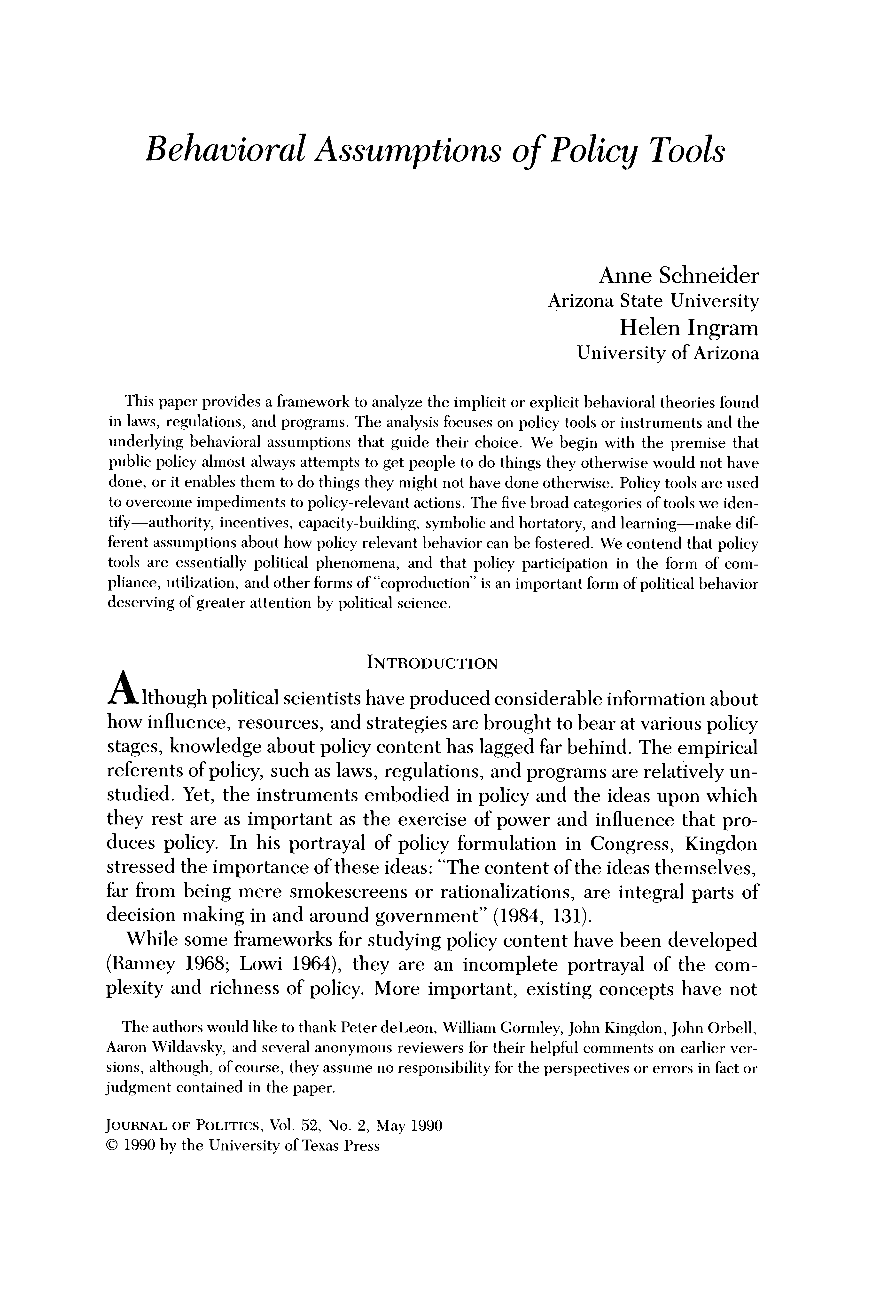

Behavioral Assumptions of Policy Tools

Anne Schneider

Arizona State University

Helen Ingram University of Arizona

This paper provides a framework to analyze the implicit or explicit behavioral theories found in laws, regulations, and programs. The analysis focuses on policy tools or instruments and the underlying behavioral assumptions that guide their choice. We begin with the premise that public policy almost always attempts to get people to do things they otherwise would not have done, or it enables them to do things they might not have done otherwise. Policy tools are used to overcome impediments to policy-relevant actions. The five broad categories of tools we iden- tify-authority, incentives, capacity-building, symbolic and hortatory, and learning-make dif- ferent assumptions about how policy relevant behavior can be fostered. We contend that policy tools are essentially political phenomena, and that policy participation in the form of com- pliance, utilization, and other forms of "coproduction" is an important form of political behavior deserving of greater attention by political science.

INTRODUCTION

A though political scientists have produced considerable information abou how influence, resources, and strategies are brought to bear at various policy stages, knowledge about policy content has lagged far behind. The empirical referents of policy, such as laws, regulations, and programs are relatively un- studied. Yet, the instruments embodied in policy and the ideas upon which they rest are as important as the exercise of power and influence that pro duces policy. In his portrayal of policy formulation in Congress, Kingdon stressed the importance of these ideas: "The content of the ideas themselves, far from being mere smokescreens or rationalizations, are integral parts of decision making in and around government" (1984, 131).

While some frameworks for studying policy content have been developed (Ranney 1968; Lowi 1964), they are an incomplete portrayal of the com-  
plexity and richness of policy. More important, existing concepts have not

The authors would like to thank Peter deLeon, William Gormley, John Kingdon, John Orbell, Aaron Wildavsky, and several anonymous reviewers for their helpful comments on earlier ver- sions, although, of course, they assume no responsibility for the perspectives or errors in fact or judgment contained in the paper.

JOURNAL OF POLITICS, Vol. 52, No. 2, May 1990 C) 1990 by the University of Texas Press

This content downloaded from 152.3.43.43 on Mon, 13 Jan 2025 21:51:30 UTC

All use subject to https://about.jstor.org/terms

|  |
| --- |
| page3image2703172816  Behavioral Assumptions of Policy Tools 511  proven to be very helpful in understanding choices among policy instru- ments, -nor in explaining their effects on the policy participation of target populations.  The purpose of this paper is to provide a framework to capture the behav- ioral attributes of policy content that political scientists can employ to bring laws, regulations, and programs more fully into our realm of analysis. The focus is on policy tools, and the explicit or implicit underlying behavioral theories guiding the choice of tools. The first section of the paper argues that policy tools are important but understudied political phenomena. The sec-  ond section contains the framework for analyzing the behavioral character- istics of tools. The conclusions show that the concepts can be used to test propositions linking policy processes to the choice of tools and propositions linking policy tools to the policy participation of target populations.  POLICY TOOLS  One of the most remarkable changes in American politics over the past 50 years has been the proliferation of tools or instruments through which governments seek to influence citizen behavior and achieve policy purposes (Salamon 1989; Doern and Wilson 1974; Dahl and Lindblom 1953). These include such commonly-used techniques as standards, direct expenditures (subsidies), sanctions, public corporations, contracts, grants, arbitration, persuasion, education, licensing, and so forth. Dahl and Lindblom (1953, 8) referred to the rapid invention of these techniques as "perhaps the greatest political revolution of our times." They attributed both political and eco- nomic importance to policy instruments, contending that the invention and utilization of a variety of tools would enable governments to solve social and economic problems without the intense cleavages and ideological debates that otherwise might occur (1953, 6).  Even though policy tools were flagged as significant political phenomena more than 35 years ago, their study has developed slowly. Among the early influential works were Edelman's emphasis on symbolism as a technique of government control and Lowi's four-fold classification of policy types (Edelman 1964; Lowi 1964, 1972). Lowi's primary contention was that each policy type (distributive, redistributive, regulatory, and constituent) pro- duced its own distinctive patterns of participation, with pluralist patterns characterizing regulatory policy and elitist characterizing distributive policy. Lowi's framework is useful for understanding some of the dynamic political consequences of different types of policies. Nevertheless, whether target populations actually comply with policy, take advantage of policy opportuni- ties, or change their behavior in some other way has not been the focus of Lowi's work. Policy-relevant behavior has either been taken for granted or  This content downloaded from 152.3.43.43 on Mon, 13 Jan 2025 21:51:30 UTC |
| All use subject to https://about.jstor.org/terms |

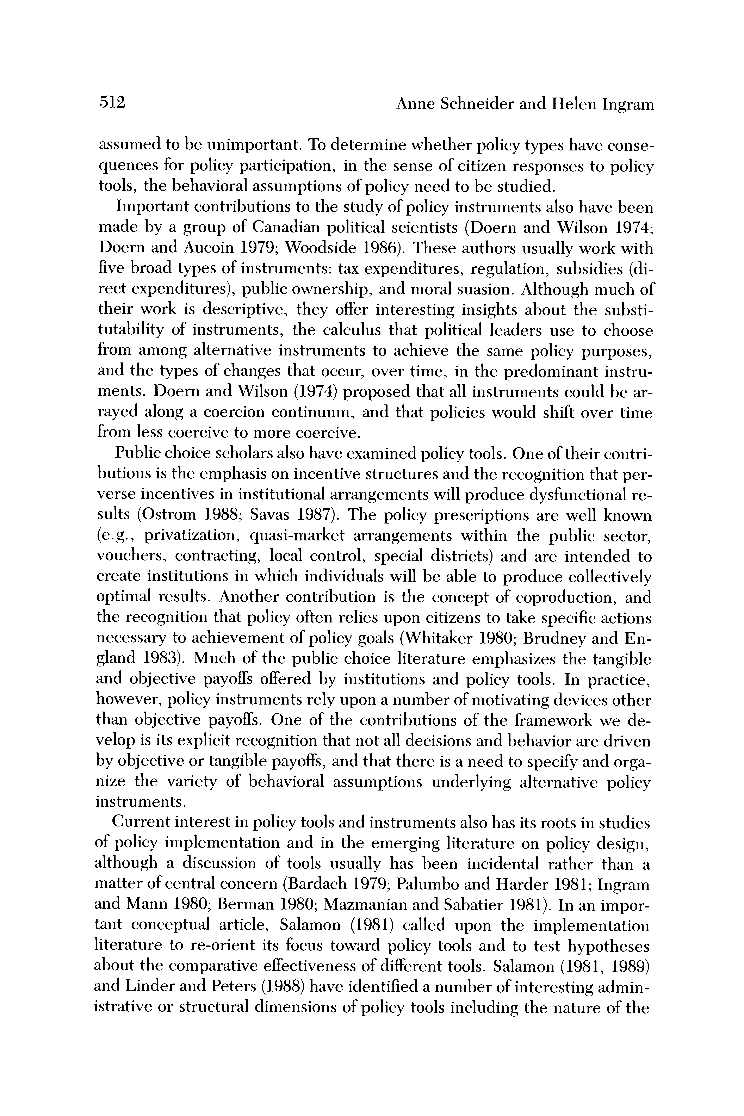

512 Anne Schneider and Helen Ingram

assumed to be unimportant. To determine wh quences for policy participation, in the sen tools, the behavioral assumptions of policy n

Important contributions to the study of po made by a group of Canadian political scien

Doern and Aucoin 1979; Woodside 1986). These authors usually work with  
five broad types of instruments: tax expenditures, regulation, subsidies (di- rect expenditures), public ownership, and moral suasion. Although much of their work is descriptive, they offer interesting insights about the substi- tutability of instruments, the calculus that political leaders use to choose  
from among alternative instruments to achieve the same policy purposes, and the types of changes that occur, over time, in the predominant instru- ments. Doern and Wilson (1974) proposed that all instruments could be ar-  
rayed along a coercion continuum, and that policies would shift over time from less coercive to more coercive.

Public choice scholars also have examined policy tools. One of their contri- butions is the emphasis on incentive structures and the recognition that per- verse incentives in institutional arrangements will produce dysfunctional re- sults (Ostrom 1988; Savas 1987). The policy prescriptions are well known (e.g., privatization, quasi-market arrangements within the public sector, vouchers, contracting, local control, special districts) and are intended to create institutions in which individuals will be able to produce collectively optimal results. Another contribution is the concept of coproduction, and the recognition that policy often relies upon citizens to take specific actions necessary to achievement of policy goals (Whitaker 1980; Brudney and En- gland 1983). Much of the public choice literature emphasizes the tangible and objective payoffs offered by institutions and policy tools. In practice, however, policy instruments rely upon a number of motivating devices other than objective payoffs. One of the contributions of the framework we de- velop is its explicit recognition that not all decisions and behavior are driven by objective or tangible payoffs, and that there is a need to specify and orga- nize the variety of behavioral assumptions underlying alternative policy

instruments.  
Current interest in policy tools and instruments also has its roots in studies

of policy implementation and in the emerging literature on policy design, although a discussion of tools usually has been incidental rather than a matter of central concern (Bardach 1979; Palumbo and Harder 1981; Ingram and Mann 1980; Berman 1980; Mazmanian and Sabatier 1981). In an impor- tant conceptual article, Salamon (1981) called upon the implementation literature to re-orient its focus toward policy tools and to test hypotheses about the comparative effectiveness of different tools. Salamon (1981, 1989) and Linder and Peters (1988) have identified a number of interesting admin- istrative or structural dimensions of policy tools including the nature of the

This content downloaded from 152.3.43.43 on Mon, 13 Jan 2025 21:51:30 UTC

All use subject to https://about.jstor.org/terms

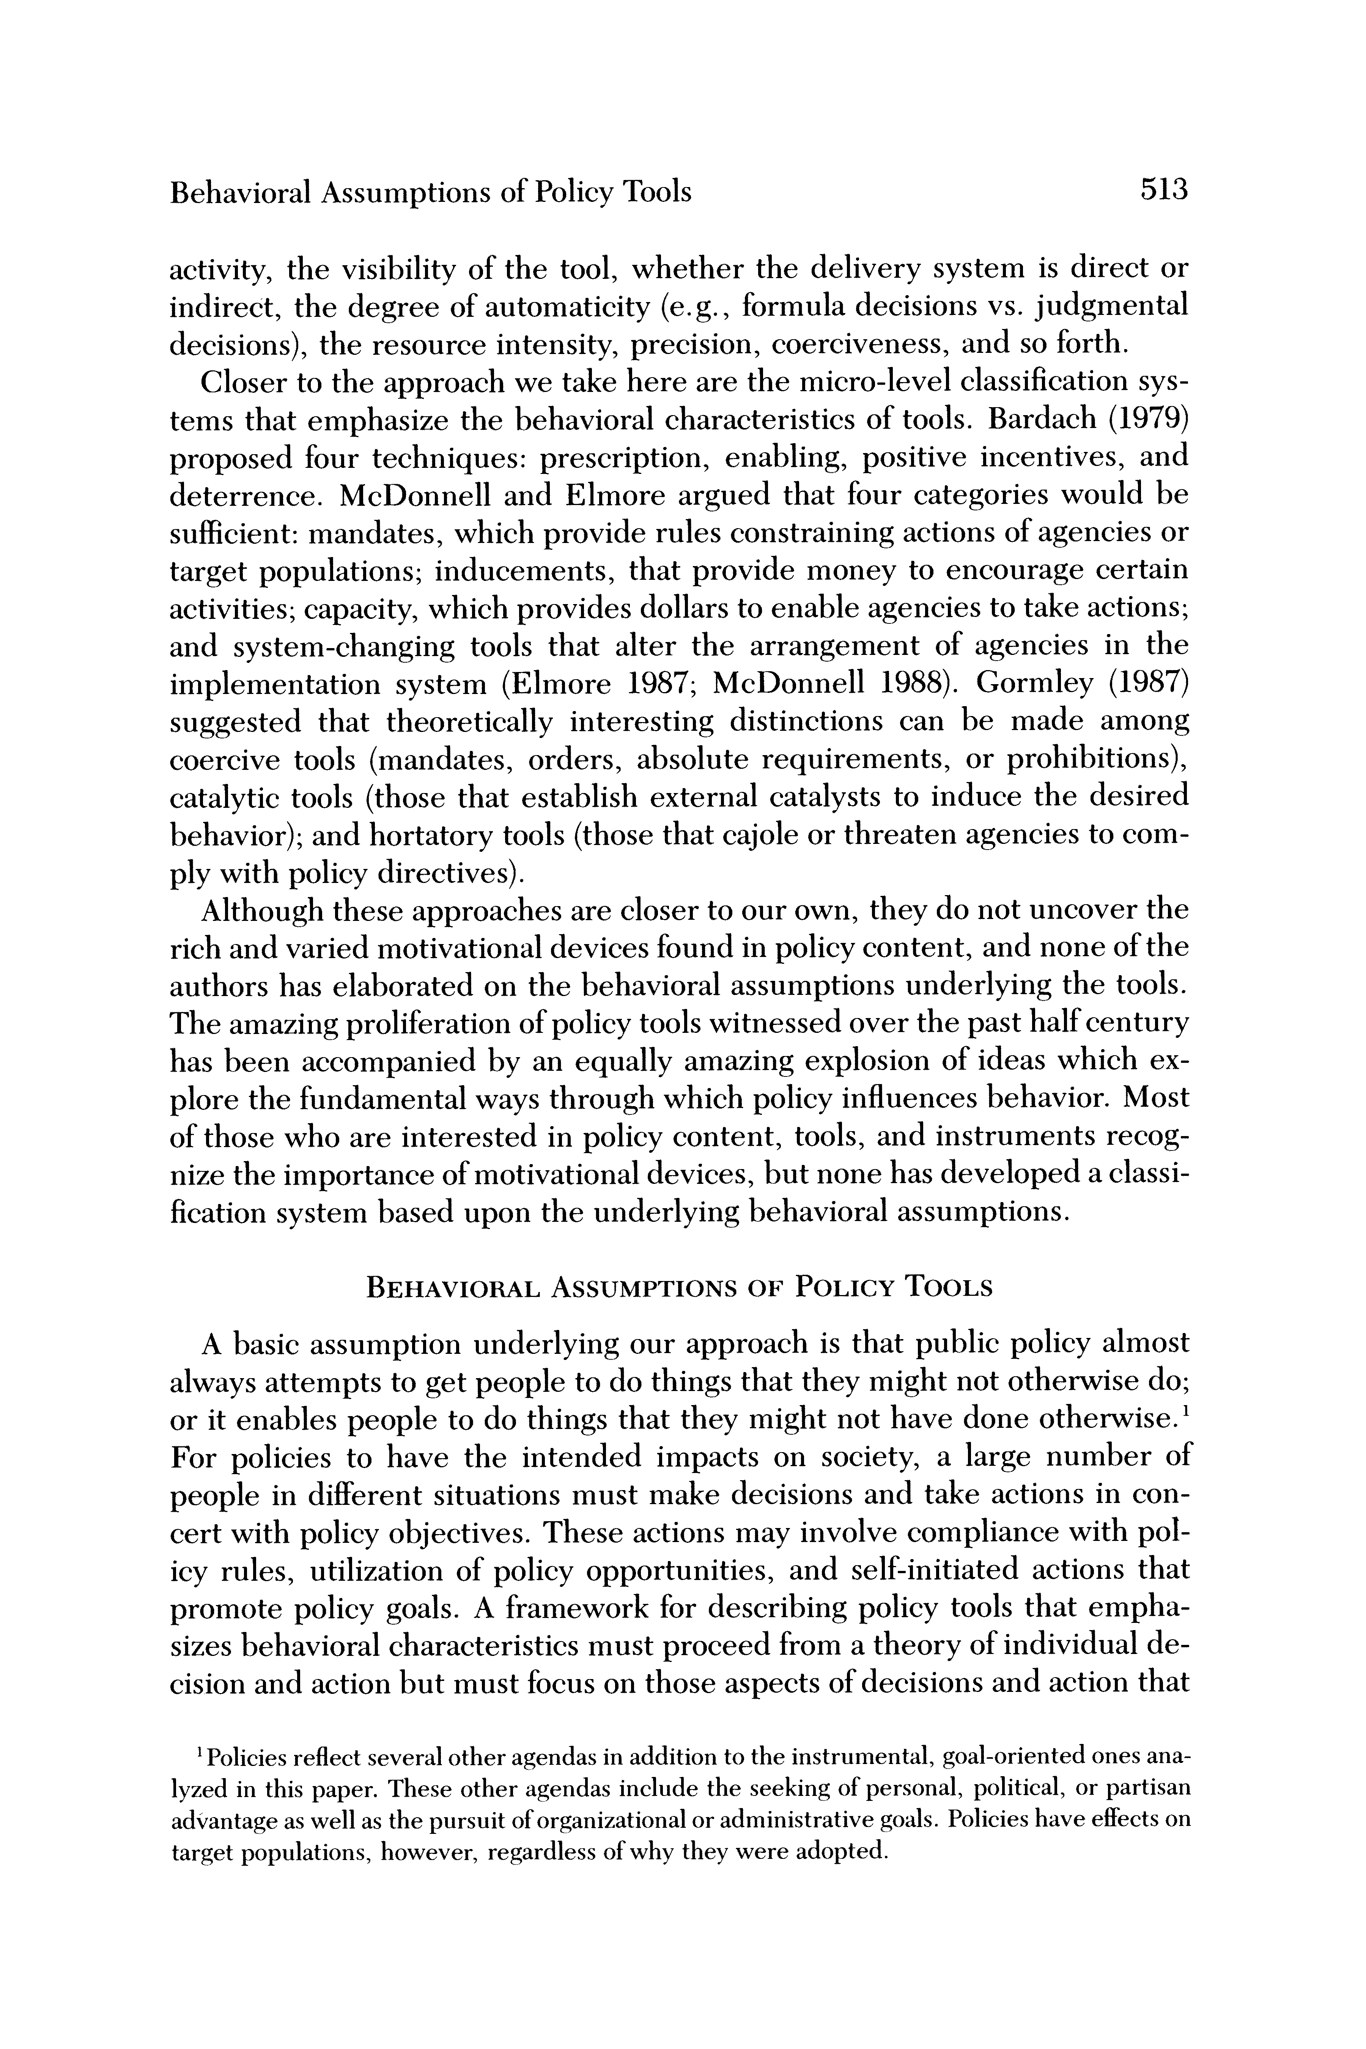

Behavioral Assumptions of Policy Tools 513

activity, the visibility of the tool, whether the de indirect, the degree of automaticity (e.g., formula decisions), the resource intensity, precision, coerci

Closer to the approach we take here are the micr tems that emphasize the behavioral characteristics of tools. Bardach (1979)  
proposed four techniques: prescription, enabling, positive incentives, and deterrence. McDonnell and Elmore argued that four categories would be

sufficient: mandates, which provide rules constraining actions of agencies or target populations; inducements, that provide money to encourage certain activities; capacity, which provides dollars to enable agencies to take actions; and system-changing tools that alter the arrangement of agencies in the implementation system (Elmore 1987; McDonnell 1988). Gormley (1987) suggested that theoretically interesting distinctions can be made among coercive tools (mandates, orders, absolute requirements, or prohibitions), catalytic tools (those that establish external catalysts to induce the desired behavior); and hortatory tools (those that cajole or threaten agencies to com- ply with policy directives).

Although these approaches are closer to our own, they do not uncover the rich and varied motivational devices found in policy content, and none of the authors has elaborated on the behavioral assumptions underlying the tools.  
The amazing proliferation of policy tools witnessed over the past half century has been accompanied by an equally amazing explosion of ideas which ex-  
plore the fundamental ways through which policy influences behavior. Most of those who are interested in policy content, tools, and instruments recog- nize the importance of motivational devices, but none has developed a classi- fication system based upon the underlying behavioral assumptions.

BEHAVIORAL ASSUMPTIONS OF POLICY TOOLS

A basic assumption underlying our approach is that public policy almost  
always attempts to get people to do things that they might not otherwise do;  
or it enables people to do things that they might not have done otherwise.'  
For policies to have the intended impacts on society, a large number of  
people in different situations must make decisions and take actions in con- cert with policy objectives. These actions may involve compliance with pol- icy rules, utilization of policy opportunities, and self-initiated actions that promote policy goals. A framework for describing policy tools that empha- sizes behavioral characteristics must proceed from a theory of individual de- cision and action but must focus on those aspects of decisions and action that

'Policies reflect several other agendas in addition to the instrumental, goal-oriented ones ana- lyzed in this paper. These other agendas include the seeking of personal, political, or partisan advantage as well as the pursuit of organizational or administrative goals. Policies have effects on target populations, however, regardless of why they were adopted.

This content downloaded from 152.3.43.43 on Mon, 13 Jan 2025 21:51:30 UTC

All use subject to https://about.jstor.org/terms

|  |
| --- |
| page6image2602894992  514 Anne Schneider and Helen Ingram  have policy "handles." Thus, the theory must emphasize variables that are causally related to decisions and actions but that can be manipulated or influ- enced by policy.  If people are not taking actions needed to ameliorate social, economic, or political problems, there are five reasons that can be addressed by policy: they may believe the law does not direct them or authorize them to take action; they may lack incentives or capacity to take the actions needed; they may disagree with the values implicit in the means or ends; or the situation may involve such high levels of uncertainty that the nature of the problem is not known, and it is unclear what people should do or how they might be motivated. Policy tools address these problems by providing authority, in- centives, or capacity; by using symbolic and hortatory proclamations to influ- ence perceptions or values; or by promoting learning to reduce uncertainty. Laws, provisions within laws, guidelines, programs, or even the practices  and routines of case workers can be described and analyzed in terms of the types of tools upon which they rely.  Authority Tools  Authority tools are one of the oldest and most common techniques used by government to achieve policy aims. These are simply statements backed by the legitimate authority of government that grant permission, prohibit, or require action under designated circumstances. Authority tools are used mainly within the hierarchical system of government to guide the behavior of agents and officials at other levels, but such tools occasionally extend to the target populations. Differing levels of intensity represented by authority tools can be revealed by arraying them along a continuum ranging from largely voluntary actions (granting permission) to those that are compulsory. These tools assume agents and targets are responsive to the organizational structure of leader-follower relationships and that lower level agents usually  will do as they are told.2 When authority tools are used in relation to the target populations, they  almost always are accompanied by other motivating devices. However, as Kelman (1981) makes clear, policy may depend on citizens doing what is ex- pected of them even without tangible payoffs. Designated radio stations, for example, tell their listeners during civil defense tests that in the event of an emergency, they will receive (and will be expected to follow) directions given over the air.  2Authority tools assume their targets are motivated by a commitment to obey laws and regula- tions without the aid of tangible incentives. Loyalty to duty is assumed to be an inherent virtue of citizens in civic life and of officials in governmental structure. Obeying authority is motivated by utilitarian goals only remotely, if at all. For instance, a surprisingly large number of motor- ists will stop for a red light in the dead of night with no visible evidence of another car on the highway.  This content downloaded from 152.3.43.43 on Mon, 13 Jan 2025 21:51:30 UTC |
| All use subject to https://about.jstor.org/terms |
| page7image2603400112  Behavioral Assumptions of Policy Tools 515  Incentive Tools  The incentive category includes tools that rely on tangible payoffs, posi- tive or negative, to induce compliance or encourage utilization. Incentive tools assume individuals are utility maximizers and will not be positively motivated to take policy-relevant action unless they are influenced, encour- aged, or coerced by manipulation of money, liberty, life, or other tangible payoffs. Within this broad category are several subtypes (inducements, charges, sanctions, and force) that rely upon subtle but important differences in the behavioral assumptions.  Inducements offer positive payoffs to encourage participation in policy- preferred activity. The underlying assumption is that individuals respond to positive incentives and that most will choose higher-valued alternatives. Economic development policy uses tax credits or waivers, grants, relaxation of standards or requirements, provision of land, and so forth to induce firms to move to particular locations. Some educational reforms contain specific awards for schools, or teachers, whose students perform at certain levels. Contracts are a type of inducement that has the added advantage of promot- ing competition among potential suppliers. Grants with highly specific pur- poses are inducements, such as the federal programs offering grants to states that agreed to remove juveniles from adult jails within a three-year period.  Charges are usually associated with standards or guidelines that define permissible limits and specify monetary charges for those who do not meet the standards or who want to exceed their quota. Charges may be used to control, limit, or allocate goods or activities, but unlike sanctions, charges are not intended to extinguish the activity or confer social disapproval upon it (see Kelman 1981). The intent is simply to control the amount of use. Charges usually are proportional to the regulatory need or to the social bur- den imposed by the activity. Some pollution control policies use charges that are calibrated so that the polluters pay for the pollution they produce. Sev- eral states use charges to discourage local communities from sending pris- oners to state institutions by charging them for each person committed above the pre-established quota for the community.  Sanctions also are associated with standards or rules that prohibit or re- quire certain activities, but sanctions imply disproportionately severe penal- ties for failure to comply.3 Sanctions are the primary tools used to enforce the criminal and civil codes. The intent is to extinguish certain kinds of behavior by raising the costs far above the proportional value of the behavior itself through fines, deprivation of life or liberty, or the social control techniques  'Many policy tools have nonutilitarian, justice-based dimensions in addition to the behavioral dimensions examined in this paper. Rewards or punishments may be distributed on the basis of deservedness, for example, rather than as techniques for influencing behavior. The normative dimension of policy tools is an important topic but beyond the scope of this paper.  This content downloaded from 152.3.43.43 on Mon, 13 Jan 2025 21:51:30 UTC |
| All use subject to https://about.jstor.org/terms |

|  |
| --- |
| page8image2591612208  516 Anne Schneider and Helen Ingram  used in probation or parole. Classical deterrence theory assumes that indi- viduals respond to the severity, certainty, and celerity (speed) of punish- ment, and in this respect it implies that individuals are utility maximizers.  The use of force, particularly incapacitation or death, physically produces the desired actions.4 Force removes opportunity from its direct recipients and also serves as a deterrent to others. Underlying the use of force is the assumption that some individuals cannot be influenced to take the actions needed by government, or that it would be too costly to produce the desired behavior. Incarceration of criminals or political opponents, the use of drugs on mentally ill patients, and take-overs of schools, railroads, or companies by the national guard are examples.  Policy tools that rely on incentives are analogous to policy games in which policy provisions serve as an experimenter offering certain positive or nega- tive payoffs to individuals, the groups to which they belong, or to the larger collectivity. Incentive policy tools manipulate the tangible benefits, costs, and probabilities that policy designers assume are relevant to the situation. In fact, target populations may perceive many other values, both tangible and intangible, in the situation. In contrast with capacity tools, incentives assume individuals have the opportunity to make choices, recognize the op- portunity, and have adequate information and decision-making skills to se- lect from among alternatives those that are in their own best interests. In contrast with symbolic and hortatory tools, incentives assume tangible re- wards or punishments (if sufficiently high, certain, and swift) will render irrelevant intangible or cultural values and reduce reliance on decision heuristics.  The instruments within the incentive category are technically substitut- able, in the sense that the same net utility could be produced for a particular action by any one of the tools. Nevertheless, there are very important differ- ences among them and important implications of the choices. Sanctions and force, for example, usually are reserved for actions that the government wants to stigmatize; whereas inducements and charges are usually associated with socially acceptable behavior. Costs of administration are expected to differ among the tools, and some produce far more visible effects than others.  4Force is an important policy tool commonly used by many governments, yet its behavioral aspects are multi-faceted and somewhat difficult to characterize. We have included force as a subtype within the broad category of incentives even though one might argue that it should be in a category of its own, or others might contend that it actually is a type of sanction and does not need to be included separately. The use of force on specific targets physically produces the in- tended behavior rather than inducing or coercing it, as is true of the other types of incentives. For this reason, force is clearly different than other sanctions. On the other hand, the use of force on one group produces the threat that similar action would be taken against others which may influence their behavior in much the same way as sanctions or inducements. Because of the dual characteristics of force, we have decided to treat it as a distinctive subtype but closely re- lated to other incentive tools.  This content downloaded from 152.3.43.43 on Mon, 13 Jan 2025 21:51:30 UTC |
| All use subject to https://about.jstor.org/terms |

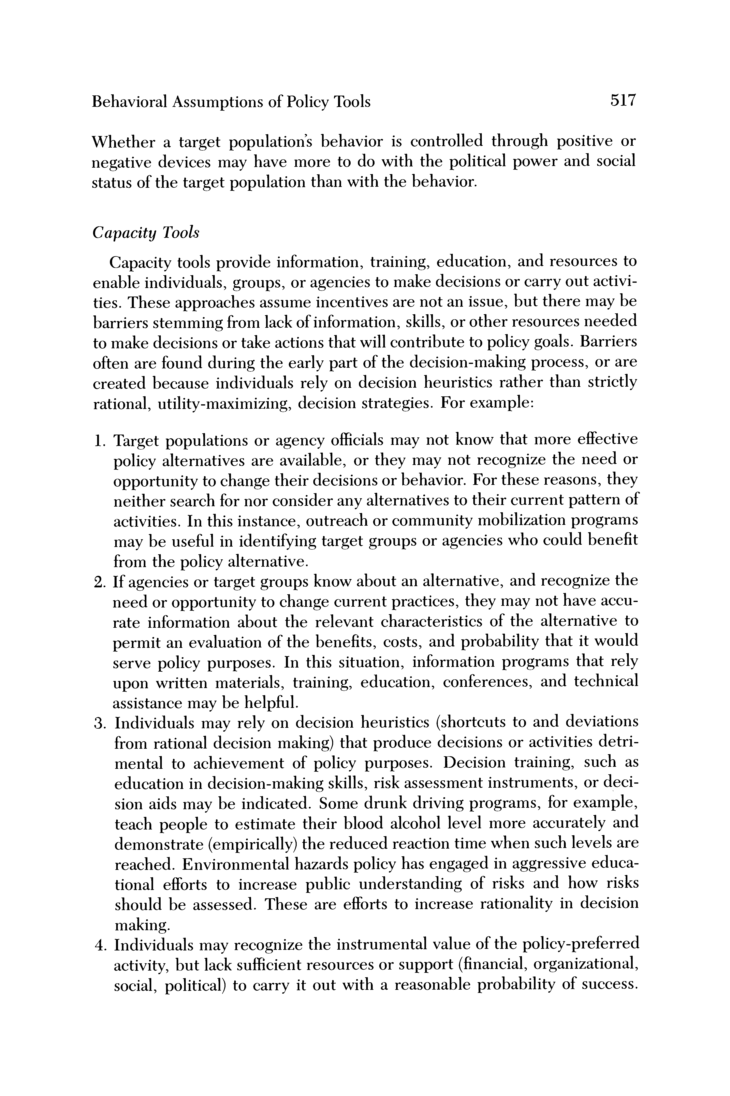

Behavioral Assumptions of Policy Tools 517

Whether a target population's behavior is controlled through positive or negative devices may have more to do with the political power and social status of the target population than with the behavior.

Capacity Tools

Capacity tools provide information, training, education, and resources to enable individuals, groups, or agencies to make decisions or carry out activi- ties. These approaches assume incentives are not an issue, but there may be barriers stemming from lack of information, skills, or other resources needed to make decisions or take actions that will contribute to policy goals. Barriers often are found during the early part of the decision-making process, or are created because individuals rely on decision heuristics rather than strictly rational, utility-maximizing, decision strategies. For example:

1. Target populations or agency officials may not know that more effective policy alternatives are available, or they may not recognize the need or opportunity to change their decisions or behavior. For these reasons, they neither search for nor consider any alternatives to their current pattern of activities. In this instance, outreach or community mobilization programs may be useful in identifying target groups or agencies who could benefit from the policy alternative.

2. If agencies or target groups know about an alternative, and recognize the need or opportunity to change current practices, they may not have accu- rate information about the relevant characteristics of the alternative to permit an evaluation of the benefits, costs, and probability that it would serve policy purposes. In this situation, information programs that rely upon written materials, training, education, conferences, and technical assistance may be helpful.

3. Individuals may rely on decision heuristics (shortcuts to and deviations from rational decision making) that produce decisions or activities detri- mental to achievement of policy purposes. Decision training, such as education in decision-making skills, risk assessment instruments, or deci- sion aids may be indicated. Some drunk driving programs, for example, teach people to estimate their blood alcohol level more accurately and demonstrate (empirically) the reduced reaction time when such levels are reached. Environmental hazards policy has engaged in aggressive educa- tional efforts to increase public understanding of risks and how risks should be assessed. These are efforts to increase rationality in decision making.

4. Individuals may recognize the instrumental value of the policy-preferred activity, but lack sufficient resources or support (financial, organizational, social, political) to carry it out with a reasonable probability of success.

This content downloaded from 152.3.43.43 on Mon, 13 Jan 2025 21:51:30 UTC

All use subject to https://about.jstor.org/terms

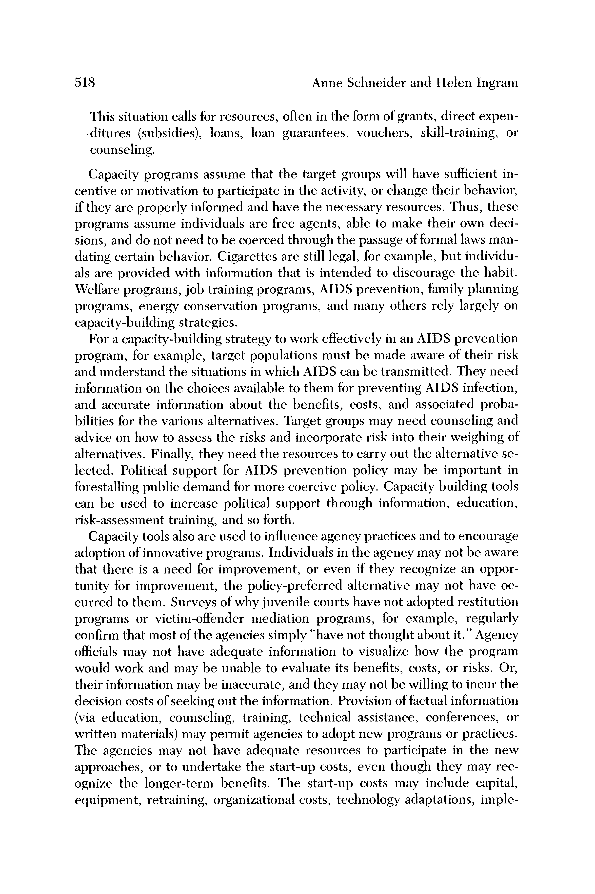

518 Anne Schneider and Helen Ingram

This situation calls for resources, often in th -ditures (subsidies), loans, loan guarantees, vouchers, skill-training, or

counseling.

Capacity programs assume that the target groups will have sufficient in- centive or motivation to participate in the activity, or change their behavior, if they are properly informed and have the necessary resources. Thus, these programs assume individuals are free agents, able to make their own deci- sions, and do not need to be coerced through the passage of formal laws man- dating certain behavior. Cigarettes are still legal, for example, but individu- als are provided with information that is intended to discourage the habit. Welfare programs, job training programs, AIDS prevention, family planning programs, energy conservation programs, and many others rely largely on capacity-building strategies.

For a capacity-building strategy to work effectively in an AIDS prevention program, for example, target populations must be made aware of their risk and understand the situations in which AIDS can be transmitted. They need information on the choices available to them for preventing AIDS infection,  
and accurate information about the benefits, costs, and associated proba- bilities for the various alternatives. Target groups may need counseling and advice on how to assess the risks and incorporate risk into their weighing of alternatives. Finally, they need the resources to carry out the alternative se- lected. Political support for AIDS prevention policy may be important in forestalling public demand for more coercive policy. Capacity building tools can be used to increase political support through information, education, risk-assessment training, and so forth.

Capacity tools also are used to influence agency practices and to encourage adoption of innovative programs. Individuals in the agency may not be aware that there is a need for improvement, or even if they recognize an oppor- tunity for improvement, the policy-preferred alternative may not have oc- curred to them. Surveys of why juvenile courts have not adopted restitution programs or victim-offender mediation programs, for example, regularly confirm that most of the agencies simply "have not thought about it." Agency officials may not have adequate information to visualize how the program would work and may be unable to evaluate its benefits, costs, or risks. Or, their information may be inaccurate, and they may not be willing to incur the decision costs of seeking out the information. Provision of factual information (via education, counseling, training, technical assistance, conferences, or written materials) may permit agencies to adopt new programs or practices.

The agencies may not have adequate resources to participate in the new approaches, or to undertake the start-up costs, even though they may rec- ognize the longer-term benefits. The start-up costs may include capital, equipment, retraining, organizational costs, technology adaptations, imple-

This content downloaded from 152.3.43.43 on Mon, 13 Jan 2025 21:51:30 UTC

All use subject to https://about.jstor.org/terms

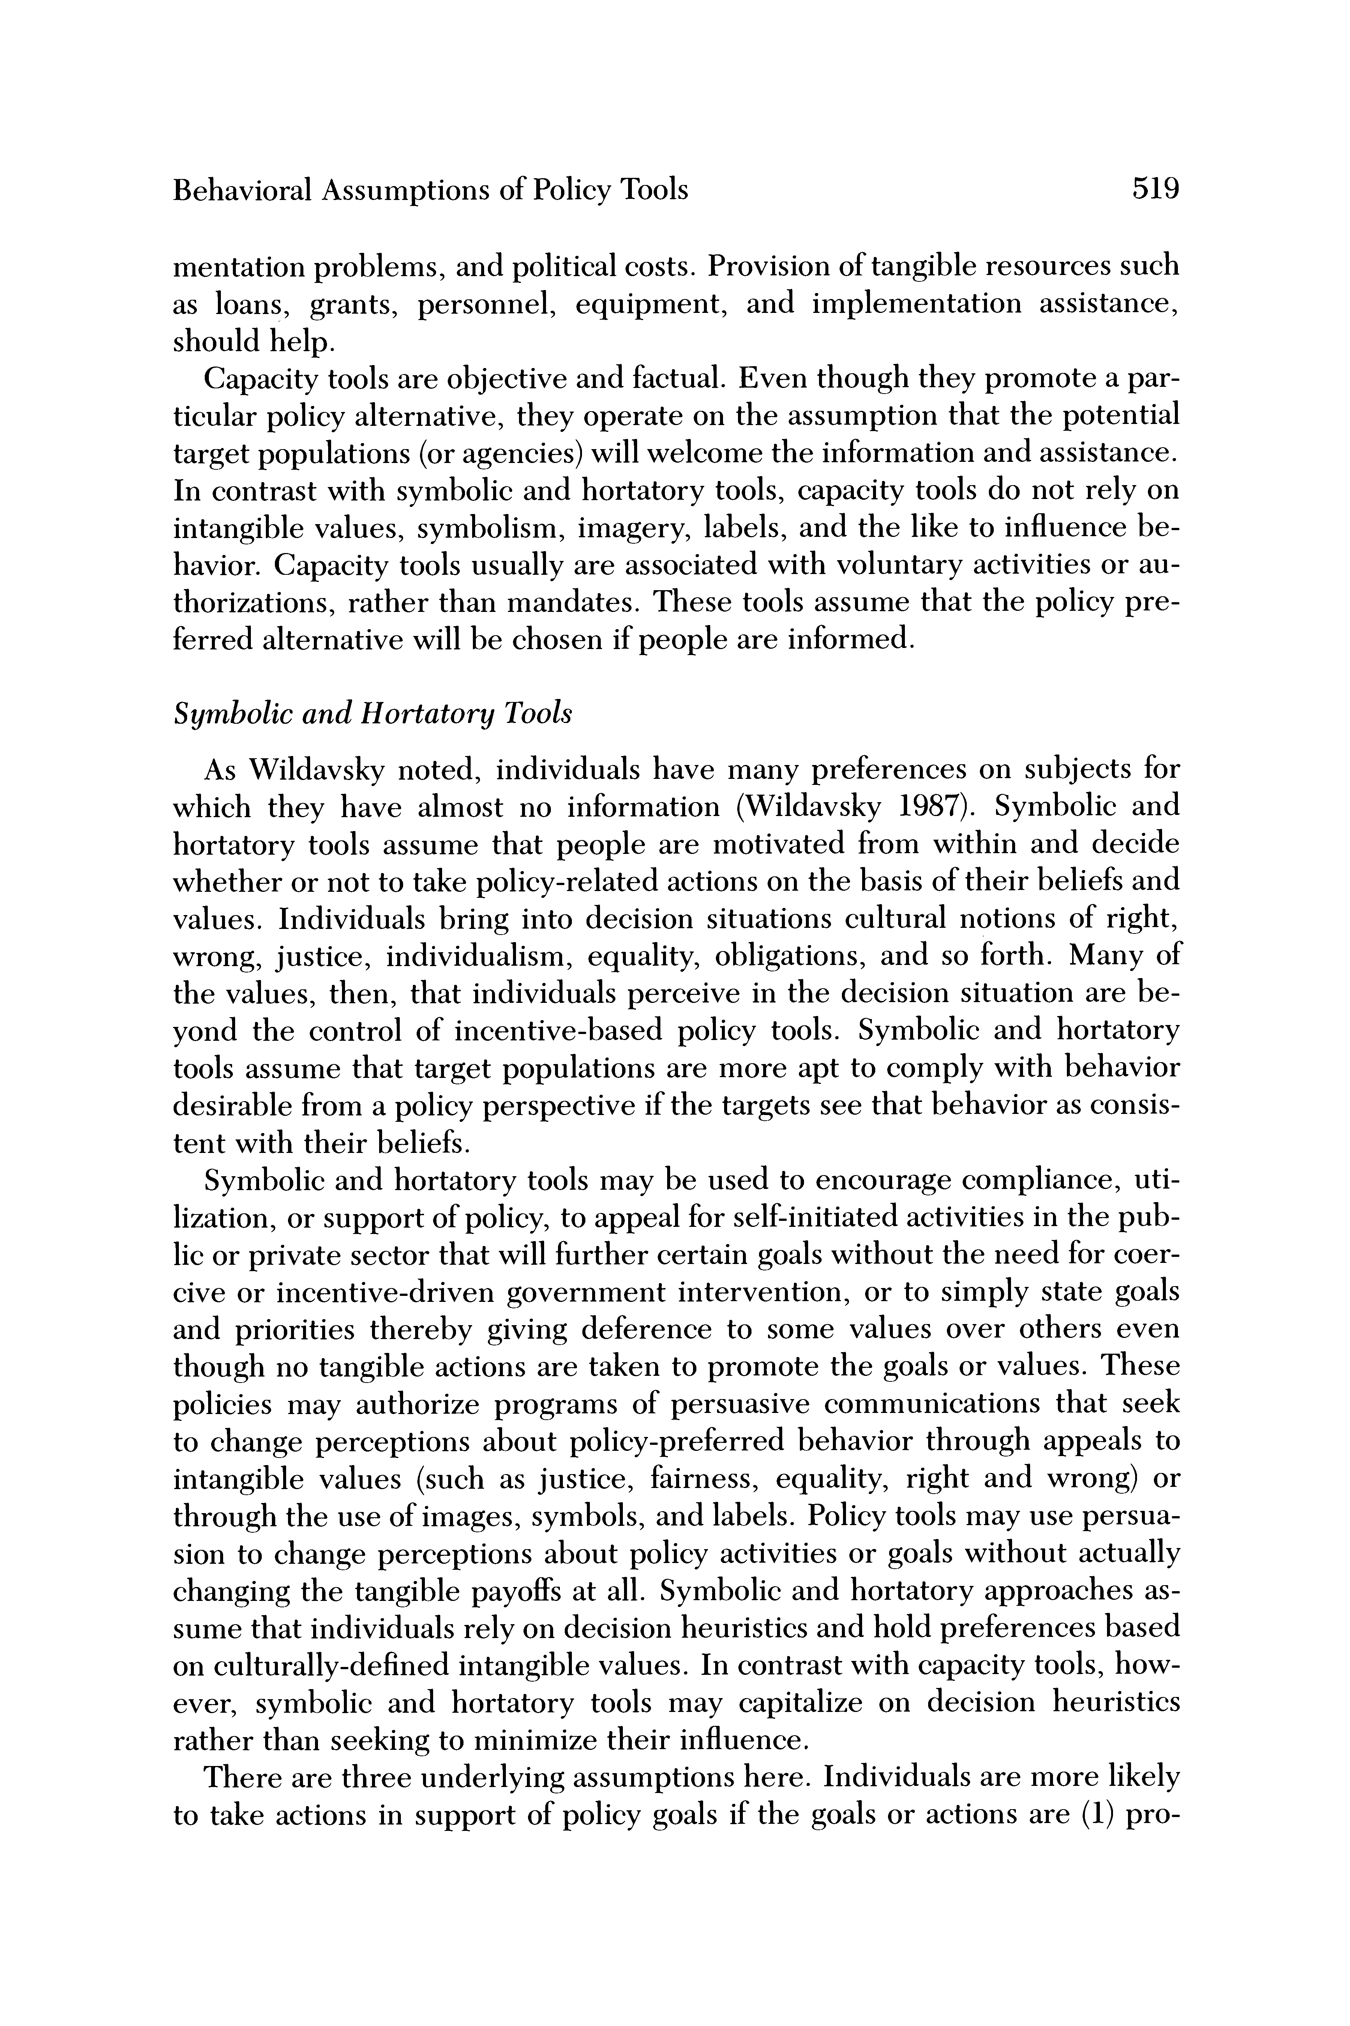

Behavioral Assumptions of Policy Tools 519

mentation problems, and political costs. Provision as loans, grants, personnel, equipment, and implementation assistance,  
should help.

Capacity tools are objective and factual. Even though they promote a par- ticular policy alternative, they operate on the assumption that the potential target populations (or agencies) will welcome the information and assistance. In contrast with symbolic and hortatory tools, capacity tools do not rely on intangible values, symbolism, imagery, labels, and the like to influence be- havior. Capacity tools usually are associated with voluntary activities or au- thorizations, rather than mandates. These tools assume that the policy pre- ferred alternative will be chosen if people are informed.

Symbolic and Hortatory Tools

As Wildavsky noted, individuals have many preferences on subjects for which they have almost no information (Wildavsky 1987). Symbolic and hortatory tools assume that people are motivated from within and decide whether or not to take policy-related actions on the basis of their beliefs and values. Individuals bring into decision situations cultural notions of right, wrong, justice, individualism, equality, obligations, and so forth. Many of

the values, then, that individuals perceive in the decision situation are be- yond the control of incentive-based policy tools. Symbolic and hortatory tools assume that target populations are more apt to comply with behavior desirable from a policy perspective if the targets see that behavior as consis- tent with their beliefs.

Symbolic and hortatory tools may be used to encourage compliance, uti- lization, or support of policy, to appeal for self-initiated activities in the pub- lic or private sector that will further certain goals without the need for coer- cive or incentive-driven government intervention, or to simply state goals and priorities thereby giving deference to some values over others even though no tangible actions are taken to promote the goals or values. These policies may authorize programs of persuasive communications that seek  
to change perceptions about policy-preferred behavior through appeals to intangible values (such as justice, fairness, equality, right and wrong) or through the use of images, symbols, and labels. Policy tools may use persua- sion to change perceptions about policy activities or goals without actually changing the tangible payoffs at all. Symbolic and hortatory approaches as- sume that individuals rely on decision heuristics and hold preferences based  
on culturally-defined intangible values. In contrast with capacity tools, how- ever, symbolic and hortatory tools may capitalize on decision heuristics rather than seeking to minimize their influence.

There are three underlying assumptions here. Individuals are more likely to take actions in support of policy goals if the goals or actions are (1) pro-

This content downloaded from 152.3.43.43 on Mon, 13 Jan 2025 21:51:30 UTC

All use subject to https://about.jstor.org/terms

|  |
| --- |
| page12image2703672720  520 Anne Schneider and Helen Ingram  moted by government officials as importan tent with their values, beliefs, and preferences, (3) associated with positive symbols, labels, images, and events. Symbolic and hortatory tools can take different forms, each relying on different underlying assumptions. Symbolic pronouncements seek to convince people of the importance and priority gov-  ernment is associating with certain activities or goals, even though actual commitment of resources or development of programs may not be underway.  Rationales go beyond simple pronouncements of government support and incorporate elaborate explanations or justifications that associate the policy- preferred activities with positive values. Rationales may emphasize that the policy contributes to freedom, equality, order, safety, preservation of tradi- tional values, efficiency, effectiveness, and so forth. Or, the rationales may focus on how the policy is in accord with the beliefs and values of particular groups. One of the assumptions here is that people develop preferences on the basis of culturally induced values, and that they need to be convinced that a policy preferred alternative fits into their value scheme. Rationales dif- fer from incentive tools in that the latter assume individuals will weigh the tangible benefits and costs, will discover that the policy-preferred behavior confers greater net value, and will comply with it. Rationales do not nec- essarily involve an objective portrayal of the policy-preferred alternative against other options; rationales may emphasize the positive aspects of the policy and seek to minimize the negative ones; rationales may emphasize ei- ther private-regarding or public-regarding values. Tools that rely on ra- tionales can be arrayed along continua reflecting the characteristics of their appeals, such as accurate versus inaccurate or private interests versus public interests.  Another common technique, labeling, involves the use of images, sym- bols, and labels to associate the preferred activities with positively valued symbols. Drug prevention policy, for example, includes a persuasive com- munications strategy with a catchy slogan, "Just Say No," and advertise- ments against drug use by nationally known sports figures. Efforts to reduce drunk driving have included information campaigns saying that drunk driv- ing is "wrong" or "immoral" or associated with negative images such as "murderers" and "criminals." Another twist on this approach has appeared  in one state with a public television ad featuring a western song, "Good Ole Boys Don't Drink and Drive." Anti-littering campaigns in Texas adopted a slogan, "Don't Mess With Texas," after analysis indicated that much of the roadside litter was attributable to males under 35.  Policy may go to considerable lengths to associate desired behavior with positive (or at least neutral) labels and avoid negative labeling. Juveniles, for example, do not commit "crimes" and are not "punished" in "prisons"; they commit "delinquent acts" and are "treated" in "training schools." Children are not "slow" or "dumb" or "stupid"; they are "learning disabled." These  This content downloaded from 152.3.43.43 on Mon, 13 Jan 2025 21:51:30 UTC |
| All use subject to https://about.jstor.org/terms |

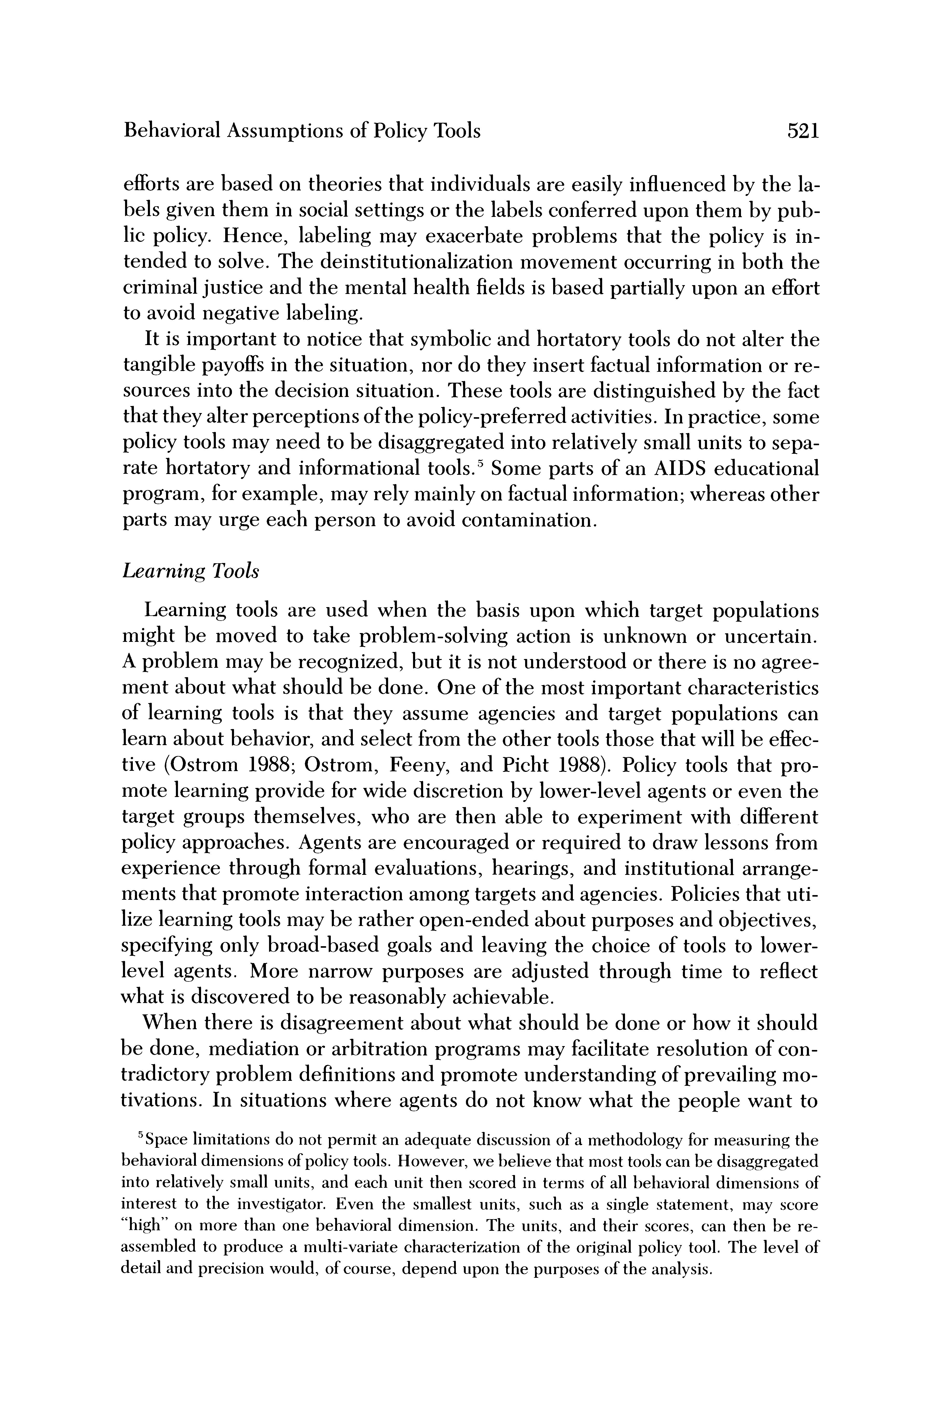

Behavioral Assumptions of Policy Tools 521

efforts are based on theories that individuals are

bels given them in social settings or the labels co lic policy. Hence, labeling may exacerbate problems that the policy is in-  
tended to solve. The deinstitutionalization movement occurring in both the criminal justice and the mental health fields is based partially upon an effort

to avoid negative labeling.  
It is important to notice that symbolic and hortatory tools do not alter the

tangible payoffs in the situation, nor do they insert factual information or re- sources into the decision situation. These tools are distinguished by the fact  
that they alter perceptions of the policy-preferred activities. In practice, some policy tools may need to be disaggregated into relatively small units to sepa- rate hortatory and informational tools.5 Some parts of an AIDS educational program, for example, may rely mainly on factual information; whereas other parts may urge each person to avoid contamination.

Learning Tools

Learning tools are used when the basis upon which target populations might be moved to take problem-solving action is unknown or uncertain.  
A problem may be recognized, but it is not understood or there is no agree- ment about what should be done. One of the most important characteristics  
of learning tools is that they assume agencies and target populations can learn about behavior, and select from the other tools those that will be effec- tive (Ostrom 1988; Ostrom, Feeny, and Picht 1988). Policy tools that pro- mote learning provide for wide discretion by lower-level agents or even the target groups themselves, who are then able to experiment with different policy approaches. Agents are encouraged or required to draw lessons from experience through formal evaluations, hearings, and institutional arrange- ments that promote interaction among targets and agencies. Policies that uti- lize learning tools may be rather open-ended about purposes and objectives, specifying only broad-based goals and leaving the choice of tools to lower- level agents. More narrow purposes are adjusted through time to reflect what is discovered to be reasonably achievable.

When there is disagreement about what should be done or how it should  
be done, mediation or arbitration programs may facilitate resolution of con- tradictory problem definitions and promote understanding of prevailing mo- tivations. In situations where agents do not know what the people want to

'Space limitations do not permit an adequate discussion of a methodology for measuring the behavioral dimensions of policy tools. However, we I)elieve that most tools can be disaggregated into relatively small units, and each unit then scored in terms of all behavioral dimensions of interest to the investigator. Even the smallest units, such as a single statement, may score

"high" on more than one behavioral dimension. The units, and their scores, can then be re- assembled to produce a multi-variate characterization of the original policy tool. The level of detail and precision would, of course, depend upon the purposes of the analysis.

This content downloaded from 152.3.43.43 on Mon, 13 Jan 2025 21:51:30 UTC

All use subject to https://about.jstor.org/terms

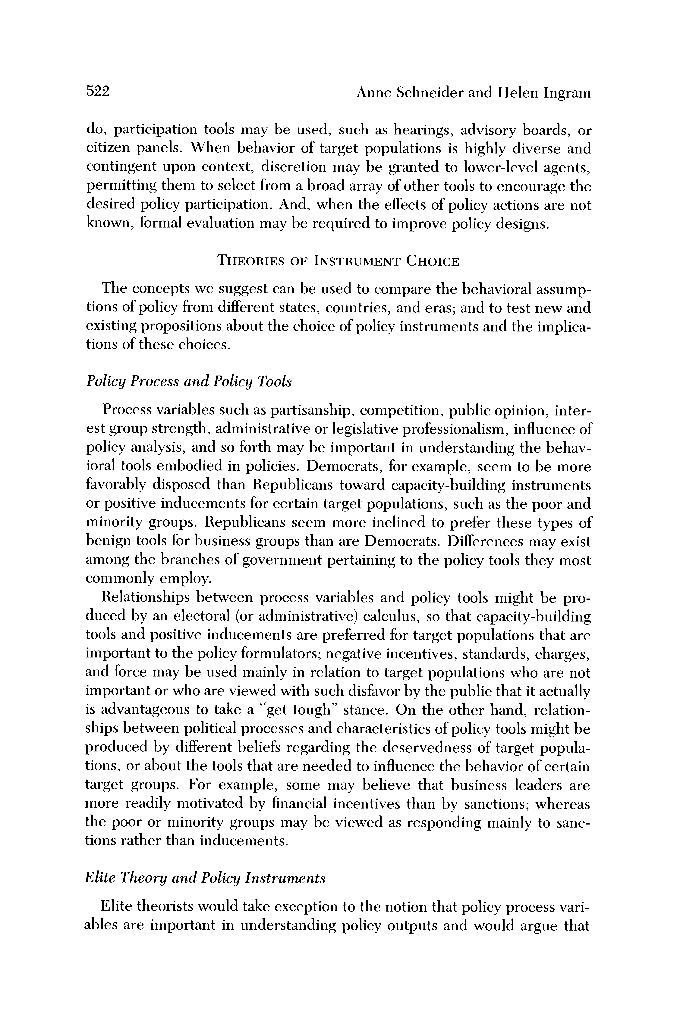

522 Anne Schneider and Helen Ingram

do, participation tools may be used, such as hearings, advisory boards, or citizen panels. When behavior of target populations is highly diverse and contingent upon context, discretion may be granted to lower-level agents, permitting them to select from a broad array of other tools to encourage the desired policy participation. And, when the effects of policy actions are not known, formal evaluation may be required to improve policy designs.

THEORIES OF INSTRUMENT CHOICE

The concepts we suggest can be used to compare the behavioral assump- tions of policy from different states, countries, and eras; and to test new an existing propositions about the choice of policy instruments and the implica- tions of these choices.

Policy Process and Policy Tools

Process variables such as partisanship, competition, public opinion, inter- est group strength, administrative or legislative professionalism, influence of policy analysis, and so forth may be important in understanding the behav- ioral tools embodied in policies. Democrats, for example, seem to be more favorably disposed than Republicans toward capacity-building instruments  
or positive inducements for certain target populations, such as the poor and minority groups. Republicans seem more inclined to prefer these types of benign tools for business groups than are Democrats. Differences may exist among the branches of government pertaining to the policy tools they most commonly employ.

Relationships between process variables and policy tools might be pro- duced by an electoral (or administrative) calculus, so that capacity-building tools and positive inducements are preferred for target populations that are important to the policy formulators; negative incentives, standards, charges, and force may be used mainly in relation to target populations who are not important or who are viewed with such disfavor by the public that it actually is advantageous to take a "get tough" stance. On the other hand, relation-  
ships between political processes and characteristics of policy tools might be produced by different beliefs regarding the deservedness of target popula- tions, or about the tools that are needed to influence the behavior of certain target groups. For example, some may believe that business leaders are  
more readily motivated by financial incentives than by sanctions; whereas  
the poor or minority groups may be viewed as responding mainly to sanc- tions rather than inducements.

Elite Theory and Policy Instruments

Elite theorists would take exception to the notion that policy process vari- ables are important in understanding policy outputs and would argue that

This content downloaded from 152.3.43.43 on Mon, 13 Jan 2025 21:51:30 UTC

All use subject to https://about.jstor.org/terms

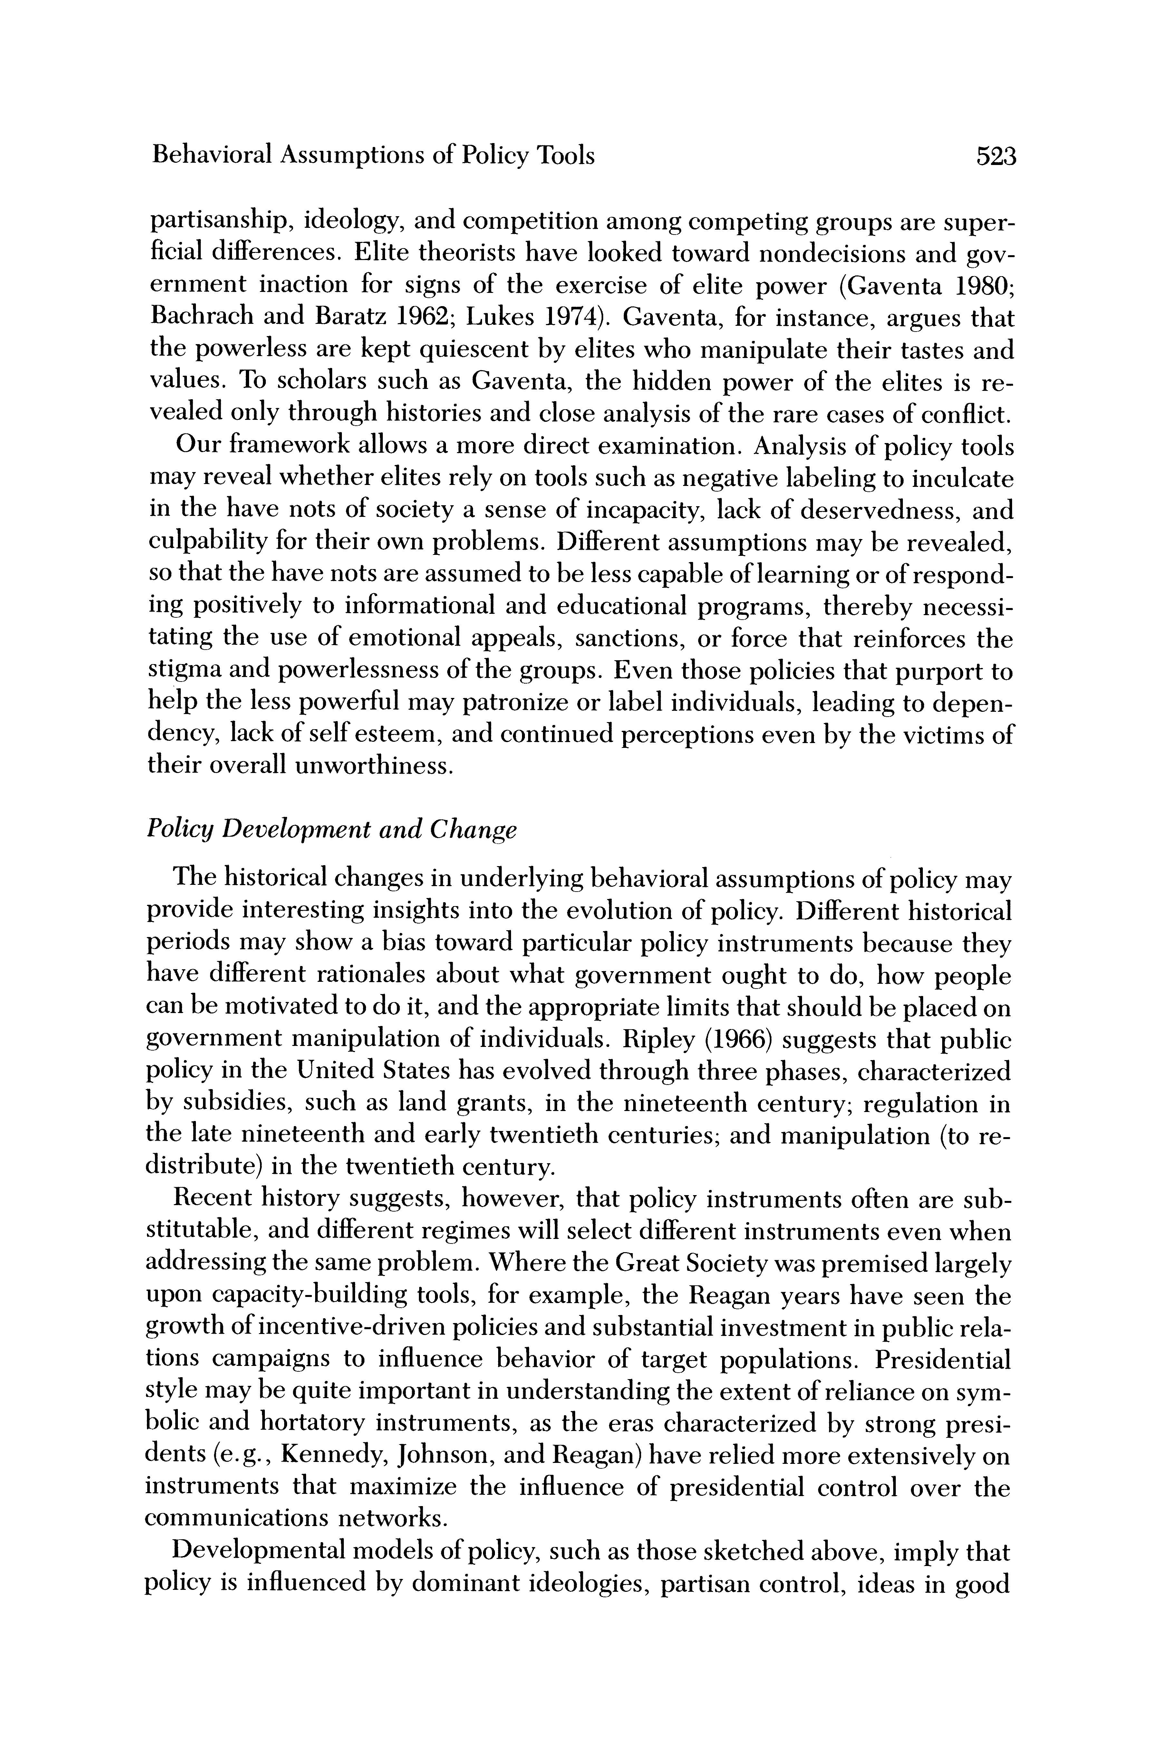

Behavioral Assumptions of Policy Tools 523

partisanship, ideology, and competition among compe ficial differences. Elite theorists have looked towar ernment inaction for signs of the exercise of elite Bachrach and Baratz 1962; Lukes 1974). Gaventa, fo the powerless are kept quiescent by elites who man values. To scholars such as Gaventa, the hidden pow vealed only through histories and close analysis of the

Our framework allows a more direct examination. A may reveal whether elites rely on tools such as negati in the have nots of society a sense of incapacity, la culpability for their own problems. Different assump so that the have nots are assumed to be less capable of ing positively to informational and educational pro tating the use of emotional appeals, sanctions, or f stigma and powerlessness of the groups. Even those po help the less powerful may patronize or label indiv dency, lack of self esteem, and continued perceptions their overall unworthiness.

Policy Development and Change

The historical changes in underlying behavioral assumptions of policy may provide interesting insights into the evolution of policy. Different historical periods may show a bias toward particular policy instruments because they have different rationales about what government ought to do, how people can be motivated to do it, and the appropriate limits that should be placed on government manipulation of individuals. Ripley (1966) suggests that public policy in the United States has evolved through three phases, characterized by subsidies, such as land grants, in the nineteenth century; regulation in the late nineteenth and early twentieth centuries; and manipulation (to re- distribute) in the twentieth century.

Recent history suggests, however, that policy instruments often are sub- stitutable, and different regimes will select different instruments even when addressing the same problem. Where the Great Society was premised largely upon capacity-building tools, for example, the Reagan years have seen the growth of incentive-driven policies and substantial investment in public rela- tions campaigns to influence behavior of target populations. Presidential style may be quite important in understanding the extent of reliance on sym- bolic and hortatory instruments, as the eras characterized by strong presi- dents (e. g., Kennedy, Johnson, and Reagan) have relied more extensively on instruments that maximize the influence of presidential control over the communications networks.

Developmental models of policy, such as those sketched above, imply that policy is influenced by dominant ideologies, partisan control, ideas in good

This content downloaded from 152.3.43.43 on Mon, 13 Jan 2025 21:51:30 UTC

All use subject to https://about.jstor.org/terms

|  |
| --- |
| page16image2701289232  524 Anne Schneider and Helen Ingram  currency, strength of groups, and so forth. during a particular historical era or regime s alternative perspective is that policy develop  learning and experience, and is relatively insulated from the biases of the current regime. If so, then changes in policy would reflect previous experi- ences more than current ideologies and might appear to be quite indepen- dent of the prevailing political forces.  The concepts we suggest could be used to describe the direction of changes that occur within a particular policy area. Doern and Wilson (1974) have ar- gued that policy begins with relatively benign strategies, such as induce- ments or capacity building, and then shifts toward more coercive policy, such as sanctions. We also sense that newer policies, where information is scanty, may rely more on learning tools and a more restricted array of ap- proaches. Over time, as policies mature, they may be characterized by a more varied set of tools, more conditional provisions regarding the situations in which certain tools are to be used, and increased reliance on statutes rather than agency guidelines.  The growth of government, then, may be observable not simply in terms of expenditures, but also in the number and variety of tools that are directed at particular target populations. These patterns may be produced by the pro- pensity of leaders to add additional tools rather than experiment with new ones when confronted with policy failure, and by the heterogeneity of con- texts in which the policy operates. Complexity and reliance upon a multi- tude of tools, may itself become too expensive and difficult to administer, thereby leading to another cycle involving devolution, deregulation, and in- creased reliance on third-party government or more simplistic approaches. Policies may follow an experimental pattern in which several strategies are tested and then more effective ones chosen. This would produce an effect opposite of that just proposed: complex or mixed strategies would tend to simplify over time. Pendulum patterns might occur, as seems to be the case in criminal and juvenile justice policies that cycle periodically between re-  habilitative and punitive approaches.  Pace and Magnitude of Change  One of the long-standing issues in public policy is whether policy evolves incrementally or with bursts of innovation, and the processes through which policy ideas diffuse from one area to another. Most of the empirical research on these issues, however, has been confined to expenditure policy or to the adoption of laws. The concepts we suggest can be used to develop interest-  ing new measures of the patterns of change and can be used to track the dif- fusion of policy ideas. Innovation, for example, could be operationalized in terms of shifts from one type of tool to another, such as shifts from induce- ments to sanctions or shifts from capacity building to incentive-driven ap-  This content downloaded from 152.3.43.43 on Mon, 13 Jan 2025 21:51:30 UTC |
| All use subject to https://about.jstor.org/terms |

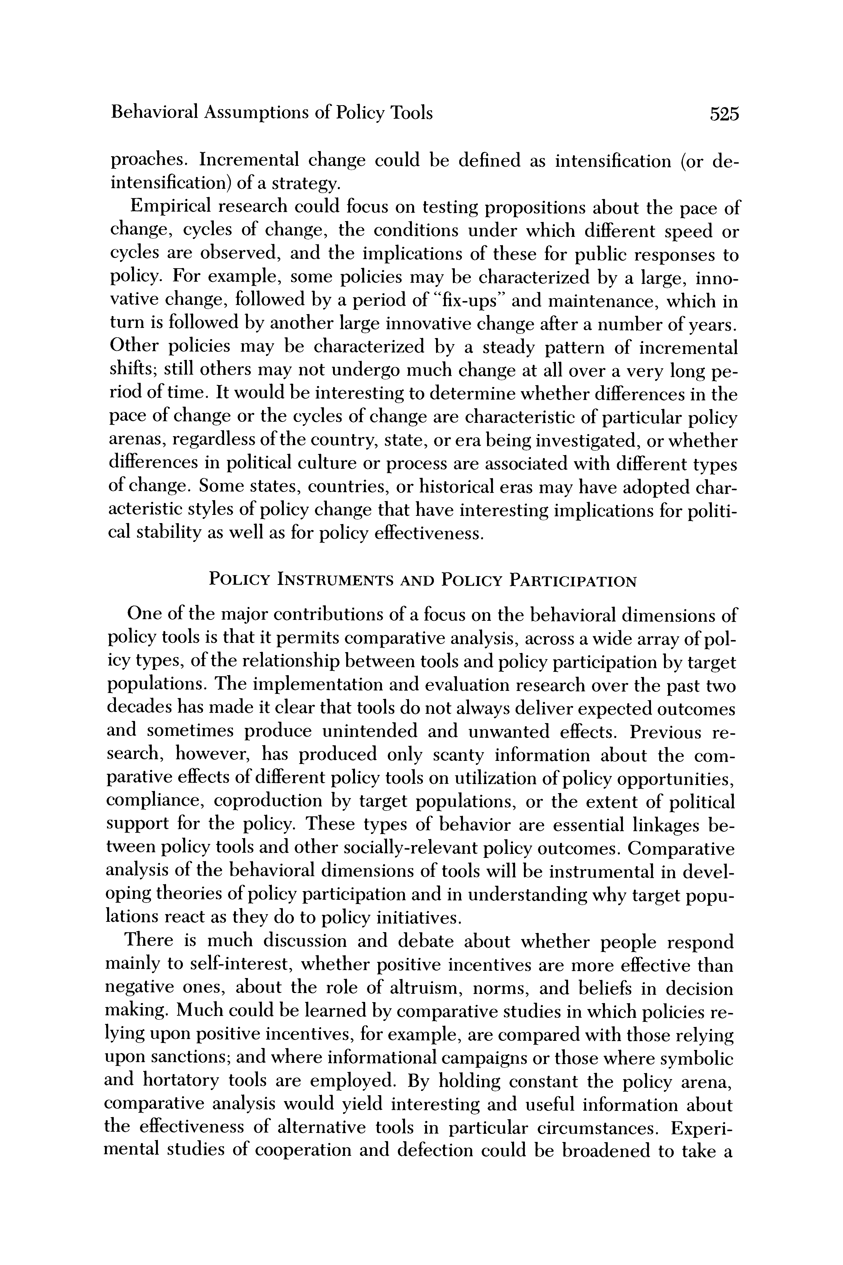

Behavioral Assumptions of Policy Tools 525

preaches. Incremental change could be defined as i intensification) of a strategy.

Empirical research could focus on testing proposit change, cycles of change, the conditions under whi cycles are observed, and the implications of these f policy. For example, some policies may be character vative change, followed by a period of "fix-ups" and turn is followed by another large innovative change af Other policies may be characterized by a steady pa shifts; still others may not undergo much change at al riod of time. It would be interesting to determine whe

pace of change or the cycles of change are characterist arenas, regardless of the country, state, or era being in differences in political culture or process are associated of change. Some states, countries, or historical eras ma acteristic styles of policy change that have interesting cal stability as well as for policy effectiveness.

POLICY INSTRUMENTS AND POLICY PARTICIPATION

One of the major contributions of a focus on the behavioral dimensions of policy tools is that it permits comparative analysis, across a wide array of pol- icy types, of the relationship between tools and policy participation by target populations. The implementation and evaluation research over the past two decades has made it clear that tools do not always deliver expected outcomes and sometimes produce unintended and unwanted effects. Previous re- search, however, has produced only scanty information about the com- parative effects of different policy tools on utilization of policy opportunities, compliance, coproduction by target populations, or the extent of political support for the policy. These types of behavior are essential linkages be- tween policy tools and other socially-relevant policy outcomes. Comparative analysis of the behavioral dimensions of tools will be instrumental in devel-

oping theories of policy participation and in understanding why target popu- lations react as they do to policy initiatives.

There is much discussion and debate about whether people respond mainly to self-interest, whether positive incentives are more effective than negative ones, about the role of altruism, norms, and beliefs in decision making. Much could be learned by comparative studies in which policies re- lying upon positive incentives, for example, are compared with those relying upon sanctions; and where informational campaigns or those where symbolic and hortatory tools are employed. By holding constant the policy arena, comparative analysis would yield interesting and useful information about the effectiveness of alternative tools in particular circumstances. Experi- mental studies of cooperation and defection could be broadened to take a

This content downloaded from 152.3.43.43 on Mon, 13 Jan 2025 21:51:30 UTC

All use subject to https://about.jstor.org/terms

|  |
| --- |
| page18image2591557488  526 Anne Schneider and Helen Ingram  more explicit policy framework and compar  binations of policy tools, within different t producing various types of policy participation (e.g., Orbell, van de Kraft, and Dawes 1988).  Perceptions about the behavioral dimensions of tools also could be used to test propositions about the pattern of politics that results, such as the propo- sitions emerging from Lowi's framework. Contention and cleavages may arise when target populations perceive that they have been singled out un- fairly, in comparison with other target groups. Lowi's framework implies that capacity building tools are positively valued and associated with the dis- tributive arena. Negative sanctions are linked to regulatory politics, and symbolic and hortatory appeals can be found in the distributive arena where ideology is involved.  The choice of policy tools may have implications for the polis. Different policy tools may vary in their effects on citizen support for the political sys- tem and the extent of alienation. Citizens are interested not only in who is expected to benefit and lose from policy, but also in the substantive effects of policy on social problems and the extent to which policy embodies their value preferences. The dimensions of policy tools that we suggest in this paper will permit research on how policy tools are viewed by citizens, and how the choice of tools affects not just citizen compliance or utilization of policy, but also citizen views of their own responsibilities and their expecta- tions of government.  Policy tools reflect the political culture. The authoritarian, individualistic, and egalitarian orientations suggested by Wildavsky should be associated with hierarchical and sanction-oriented tools for the authoritarian cultures; incentive-driven tools for the individualistic culture; and capacity-building  or symbolic tools for the egalitarian cultures (Wildavsky 1987). But tools may also create their own culture, thereby increasing the probability of their own effectiveness. Societies that rely on symbolic and hortatory tools, for ex- ample, may produce citizens who respond mainly to symbolic appeals, and  who are less capable of diagnosing or countering government rationales, even when such rationales are based on illogical or nonfactual assertions. So- cieties that rely on incentives may create the need for an ever-increasing scale of inducements and sanctions, as individuals become less and less will- ing to take policy-preferred actions simply because of their beliefs in the basic norms of citizenship.  CONCLUSIONS  In this paper we have argued that the behavioral dimensions of policy are an important but understudied aspect of politics. The framework we present should enable political scientists to identify policy tools or instruments con-  This content downloaded from 152.3.43.43 on Mon, 13 Jan 2025 21:51:30 UTC |
| All use subject to https://about.jstor.org/terms |
| page19image2734724400  Behavioral Assumptions of Policy Tools 527  tained in laws, regulations, and programs; and should facilitate an analysis of the implicit or explicit behavioral theories upon which they rely. Policy tools are techniques the government uses to achieve policy goals. For policy goals to be realized, target populations may need to comply with policy directives, utilize policy opportunities when these are offered, or engage in other forms of coproduction to promote socially desired results. These citizen actions are forms of policy participation that take place every day, by every individual, and that have a profound impact on the allocation of values for society. Policy tools act as independent variables, initiating a chain of effects that have im- portant political consequences. Yet, very little systematic attention has been given to policy instruments and even less attention has been focussed on the behavioral characteristics through which effects on target populations are produced.  The framework we present clusters tools on the basis of their underlying motivational strategies. Authority tools rely on the inherent legitimacy found in hierarchical arrangements. Incentive tools assume individuals are utility maximizers who will change their behavior in accord with changes in the net tangible payoffs offered by the situation. Capacity tools assume individuals may lack information, resources, skills, and may rely on decision heuristics (shortcuts or rules of thumb), but that these biases and deficiencies can be corrected by policy. Symbolic and hortatory tools assume individuals are motivated from within, and that policy can induce the desired behavior by manipulating symbols and influencing values. Learning tools assume agents and targets do not know what needs to be done, or what is possible to do, and that policy tools should be used to promote learning, consensus building, and lay the foundation for improved policy.  Public policies can be described in terms of their underlying behavioral assumptions, and variables can be created indicating the extent to which the policies rest upon different assumptions. Empirical research can then be undertaken to analyze the patterns of change in policy tools, determinants of change, factors that are related to the choice of different types of tools, the effects of the tools on the policy participation of target populations, and the effect of different tools in longer-range changes in political attitudes and po- litical culture.  The framework we have proposed brings together the behavioral dimen- sions of policy instruments with the concept of policy participation; an im- portant but largely neglected form of political behavior. By focusing on the behavioral dimensions of policy tools found within policy designs, political scientists may be able to advance knowledge about the conditions under which target populations will contribute to preferred policy outcomes.  Manuscript submitted 26 September 1988 Final manuscript received 22 August 1989  This content downloaded from 152.3.43.43 on Mon, 13 Jan 2025 21:51:30 UTC |
| All use subject to https://about.jstor.org/terms |

